**Background**

In this era of technology, services managed by devices or systems are widely used. These systems are being used by private companies, governments, business people or even schools. The Buffet Restaurant Reservation System is proposed to improve the manual reservation of the restaurant. Moreover, it is intended to speed up the seating arrangements of the customers in a more systematic way. This system will not only lessen time for the receptionists but also the waiting time of the walk in customers to stay for their line. Furthermore, this system provides a more manageable and efficient way of reserving seats for the customers in a restaurant.

**Goals**

* To be able to create a buffet restaurant reservation system
* To design a restaurant seat plan for the system
* To create a front-end code for the system
* To create a back-end code to be connected to the front-end software

**Scope**

The Buffet Restaurant Reservation System is a system created using the language C# and Microsoft Access in Visual Studio. The system is limited to desktop application and mobile application will not be used. It will have the main page wherein the logo, navigation bar, and form are displayed. Home, Calendar and Floor Plan is shown in the navigation bar. The form in the main page comprises of the customer’s full name, contact number, number of persons to be seated, date of the reservation, and time of meal either breakfast, lunch or dinner. It will also include clear and next buttons. The clear button is used to delete all the input data while next button is used to proceed to the next page which is the restaurant’s floor plan. The floor plan shows the top view of the restaurant. The tables are clickable so that the selected one will be reserved for the customer. After that, if the customer is done selecting seats, a confirmation slip containing the reference number and data inserted in the main menu’s form will be displayed. Furthermore, the system is operated by the system and not the customer. The customers can also tell the receptionist to edit or cancel their reservation. The customers can reserve only two weeks before the said date. The system is only limited of reserving seats. The ordering or selecting of food is not covered by the system.

**Key Stakeholders**

|  |  |
| --- | --- |
| Client | Engr. Frank Anthony Chin |
| Project manager | Gina R. Gutierrez |
| Project team members | Joyce A. Bersola(Front-end Developer), Dominador B. Pilapil Jr.(Back-end Developer), Mara Yssel D. Rabadon(QA/ Tester). |

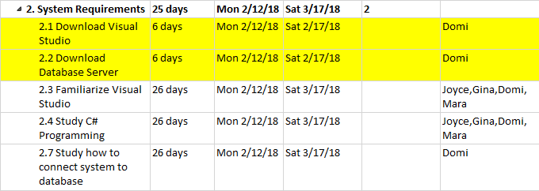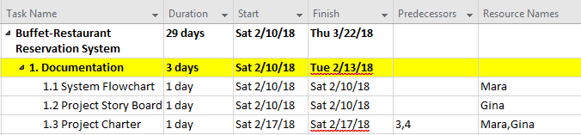**Project Milestones**   
The yellow highlights are the following milestones of the project.

**2.5 Study how to**

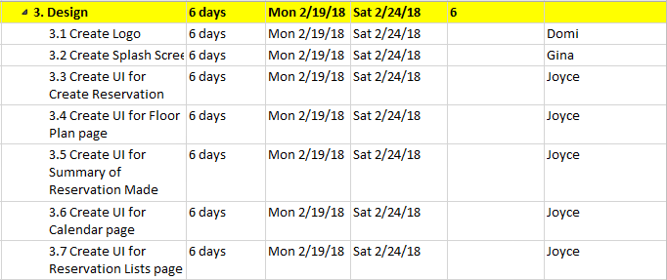

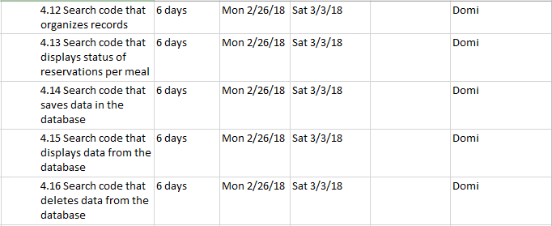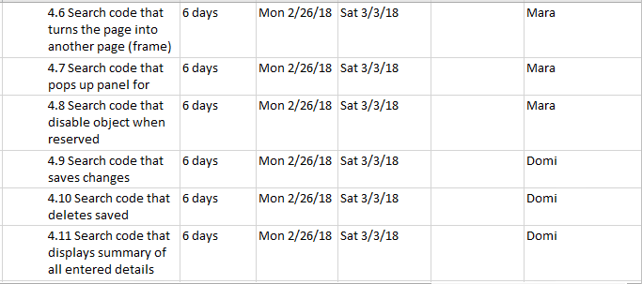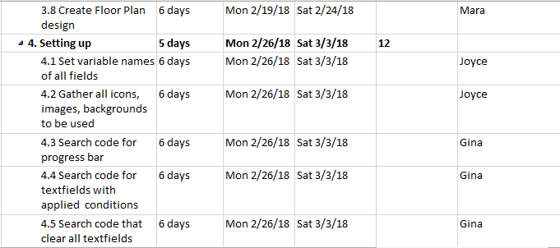

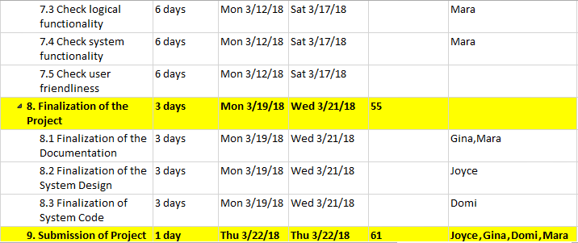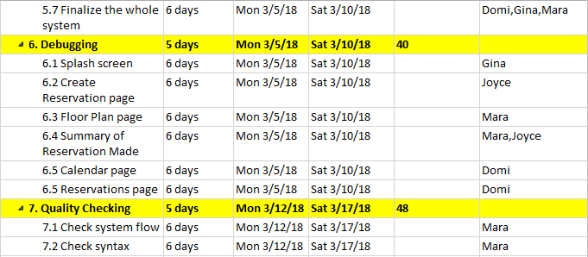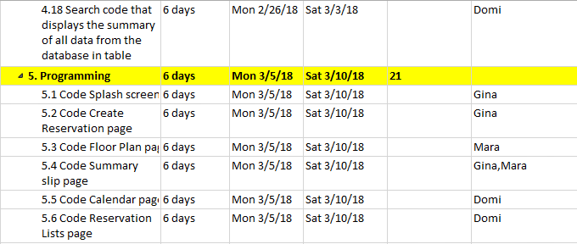

**6.6 Reservations page 6 days**

**Project Budget**

|  |  |  |  |  |
| --- | --- | --- | --- | --- |
|  | **PER PC** | **X 4** | **PER DAY** | **8 DAYS** |
| **Hardware Cost** |  |  |  |  |
| Server Hardware | 10.00 | 40.00 | 40.00 | 320.00 |
| Network Upgrades | 0.00 | 0.00 | 0.00 | 0.00 |
| Desktop hardware | 100.00 | 400.00 | 400.00 | 3,200.00 |
| **HARDWARE TOTAL** | **110.00** | **440.00** | **440.00** | **3,520.00** |
|  |  |  |  |  |
| **Software Cost** |  |  |  |  |
| Product License | 0.00 | 0.00 | 0.00 | 0.00 |
| Product Per-User Charges | 0.00 | 0.00 | 0.00 | 0.00 |
| Database | 0.00 | 0.00 | 0.00 | 0.00 |
| Operating System Software | 50.00 | 200.00 | 200.00 | 1,600.00 |
| Additional Server Software | 20.00 | 80.00 | 80.00 | 640.00 |
| Additional Network | 10.00 | 40.00 | 40.00 | 320.00 |
| **SOFTWARE TOTAL** | **80.00** | **320.00** | **320.00** | **2,560.00** |
|  |  |  |  |  |
| **Consulting** |  |  |  |  |
| Third-Party - Technical | 0.00 | 0.00 | 0.00 | 0.00 |
| Third-Party - Business | 15.00 | 60.00 | 60.00 | 480.00 |
| Deployment | 0.00 | 0.00 | 0.00 | 0.00 |
| Upgrade | 0.00 | 0.00 | 0.00 | 0.00 |
| **CONSULTING TOTAL** | **15.00** | **60.00** | **60.00** | **480.00** |
|  |  |  |  |  |
| **Training** |  |  |  |  |
| Trainer | 0.00 | 0.00 | 0.00 | 0.00 |
| **TRAINING TOTAL** | **0.00** | **0.00** | **0.00** | **0.00** |
|  |  |  |  |  |
| **Personnel-Additional** |  |  |  |  |
| Project Manager | 0.00 | 0.00 | 1,515.00 | 12,120.00 |
| Front-end Developer | 0.00 | 0.00 | 642.00 | 5,136.00 |
| Back-end Developer | 0.00 | 0.00 | 642.00 | 5,136.00 |
| QA/Tester | 0.00 | 0.00 | 1,020.00 | 8,160.00 |
| **PERSONNEL TOTAL** | **0.00** | **0.00** | **3,819.00** | **30,552.00** |
| **PROJECT TOTAL** |  |  |  | **34,872.00** |

**Constraints, Assumptions, Risks and Dependencies**

|  |  |
| --- | --- |
| Constraints | The length of the project is 2 months. There will be limited time to create the project.  The project consists of beginners. It will take time to further learn and be familiar to the tools to be used in the system.  Members are not always updated with the status of the project.  Use of Trello and Git are required.  Codes must be written in C# and use Microsoft Access as its database.  VB.net must be used to build the system. |
| Assumptions | Security will not be addressed in the system.  There are no bugs in Visual Studio and Microsoft Access.  The software applications to create the system are easy to use. |
| Risks and Dependencies | The organization is restructured so that different management is responsible for the project.  Changes to system requirements may occur.  Staffs are ill or critical at times in the project.  The back-end developer depends on the Microsoft access to be connected to visual studio.  Activities given or set must be finished first before proceeding to the next activity. |

**Approval Signatures**

|  |  |  |  |
| --- | --- | --- | --- |
|  |  |  |  |
| Engr. Frank Anthony Chin, Project Client |  |  | Gina R. Gutierrez,  Project Manager |